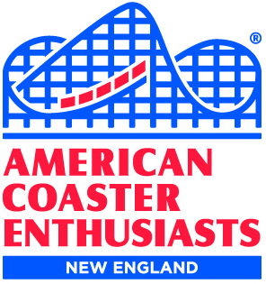
Presents
The Great Nor’Easter
Saturday, MARCH 2, 2024
Location: Six Flags New England
Contact: Karen April - kapril@aceonline.org

It’s the ACE New England annual off-season event being held on Saturday, March 2, 2024! The event will take place at Six Flags New England, and will feature presentations from area amusement parks, a delicious lunch, games, door prizes, and surprises! Meet friends old and new, too.
TENTATIVE SCHEDULE:
10 -10:30 am: Event check-in
10:30 am-12:30 pm Presentations
12:30-2 pm: Lunch
2 pm – 4 pm: Presentations

REGISTRATION INCLUDES:
Admission to The Great Nor’Easter
A catered lunch
and
The 9th Annual ACE NEW ENGLAND PHOTO CONTEST at The Great Nor’Easter
(For contest rules email: rozana@aceonline.org)
LUNCH MENU:
Snacks and drinks all day, and lunch will include variety of soups, salads, sandwiches and dessert.
Note - gluten free, vegetarian and vegan meal options must be selected when registering for the event.

PRICING:
ACE Member: $28.25
Guest: $33.50

REGISTRATION DEADLINE: Sunday, February 25, 2024 at 11:59 p.m. Eastern Time
ACE members may bring up to two guests.
Registration link: http://www.acenewengland.org/?p=99861

ALSO:
ACE members attending The Great Nor'easter can receive free shipping on orders of $50 or more
from the online ACE General Store https://www.aceonline.org/page/Merchandise
The code is: thegreatnoreaster24 The code will be valid 3/2 - 3/10

