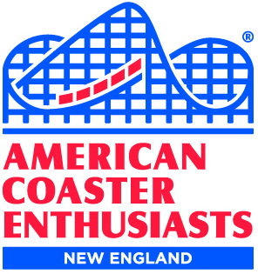
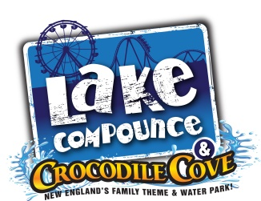
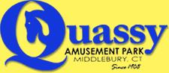
ACE New England's
Two-fer Connecticut!
Saturday, July 18, 2020

TWO Parks!
TWO Meal Vouchers!
TWO ERT Sessions (on 3 coasters)
ONE Price!

We’ll begin our day at Quassy Amusement Park, with ERT on Wooden Warrior.
Enjoy the park, using your meal voucher* to grab something for lunch.

After Quassy, head over to Lake Compounce.
You’ll have a meal voucher for dinner.
Night ERT on Boulder Dash the Mountain Coaster and Phobia Phear Coaster
once the park closes. Snacks will be offered during ERT!

Each ACE member may bring up to 2 guests.

ONLINE REGISTRATION DEADLINE: MIDNIGHT, JULY 14, 2020 |  |  |  |  |  |  |  | http://www.acenewengland.org/?p=85754
 |  |  |  |  |  |  |  | (Surcharge applies)
ACE MEMBERS = $71 |  | ACE MEMBERS with Lake Compounce Season Pass = $51
GUESTS = $81 |  | GUESTS with Lake Compounce Season Pass = $61
 |  |  |  |  |  |  |  |  | ACE # or Guest | Amount
Name: |  |  |  | City: |  |  |  |  |  | $
Email: |  |  |  |  | State:
Name: |  |  |  | City: |  |  |  |  |  | $
Email: |  |  |  |  | State:
Name: |  |  |  | City: |  |  |  |  |  | $
Email: |  |  |  |  | State:
Name: |  |  |  | City: |  |  |  |  |  | $
Email: |  |  |  |  | State:
Name: |  |  |  | City: |  |  |  |  |  | $
Email: |  |  |  |  | State:
Name: |  |  |  | City: |  |  |  |  |  | $
Email: |  |  |  |  | State:
 |  |  |  |  |  |  |  |  | TOTAL | $
MAILED IN REGISTRATIONS MUST BE RECEIVED BY JULY 14, 2020
Make check out to Russell Ozana and mail to 157 Crosby Road, Dracut, MA 01826-1370

Event Schedule:

- 8:30 - 9 a.m. Check in at Quassy Amusement Park – free parking for attendees
- 9 -11 a.m. ERT on Wooden Warrior
- 11 a.m. Group Photo in the field behind Wooden Warrior
- 11 a.m.-9 p.m. Quassy Amusement park open to the public and you

Arrive at Lake Compounce at your discretion (park is open 11 a.m. to 9 p.m.)
A Lake Compounce parking pass will be emailed to registered attendees.
Print the pass at home and show the pass + your ACE membership card for free standard parking!

- 6:00 p.m. Group photo in front of the Phobia Phear Coaster sign
- 9:00 p.m. Lake Compounce closes. Once given the ‘all clear’, one hour of ERT begins on
Boulder Dash and Phobia Phear Coaster (with snacks!)

*The Quassy meal voucher will be good for one non-fish basket of your choice, and includes one large soda
or one cup of domestic draft beer.

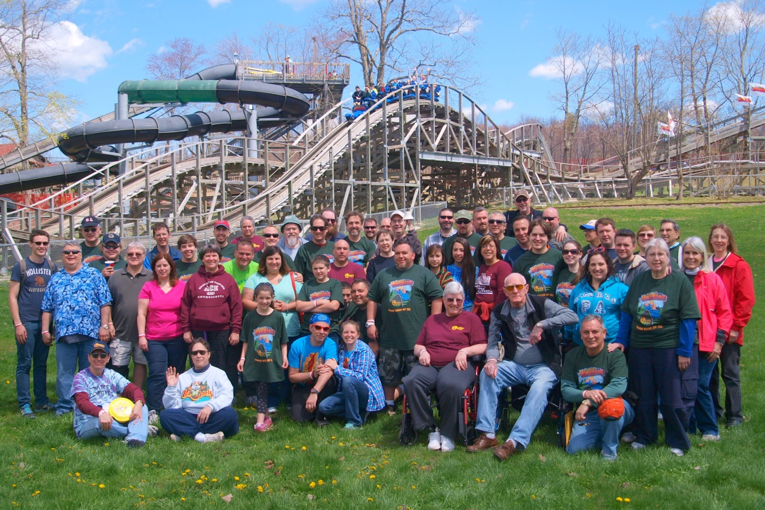
2015 Group photo

NO REFUNDS ***** NO RAIN CHECKS ***** NO EXCHANGES ***** NO WHINING

The payment of registration fees by, for or on behalf of participants releases and holds harmless American Coaster Enthusiasts, Inc. and its Officers, Executive Committee Members, Regional Representatives and other representatives as well as Quassy Amusement Park and Lake Compounce Family Theme Park, from any and all liabilities related to those activities. The payment of registration fees by, for or on behalf of participants acknowledges that an inherent risk of exposure to COVID-19 exists in public places where people are present and that attendees voluntarily assume all risks to exposure to COVID-19 and holds harmless American Coaster Enthusiasts, Inc. and its Officers, Executive Committee Members, Regional Representatives and other representatives as well as Quassy Amusement Park and Lake Compounce Family Theme Park, from any and all illness and injury.

