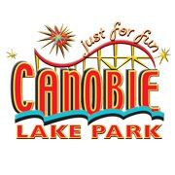
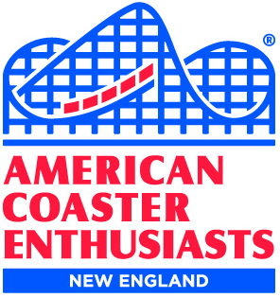
The New England Region of
American Coaster Enthusiasts
and
Canobie Lake Park
present

THE GREAT NOR’EASTER
2020

Saturday, February 29, 2020
11 a.m. to 4 p.m.
(check in begins at 10 a.m.)

~~~ CANOBIE LAKE PARK WILL BE PROVIDING LUNCH ~~~
Please advise of any food allergies when you RSVP

Park Reps! Door Prizes! Food! Other Surprises!

If you’ll be joining us, you must contact Rus Ozana by February 24 so we can plan for lunch:
rozana@ACEonline.org or call 617-816-9943

Due to space/seating limitations, only ACE members may attend (sorry, no guests).
A suggested donation of $5 per person will be taken at the door.

LOCATION
Training Room
Check in begins at 10 a.m.
Room is on 2nd floor and no elevator is available.
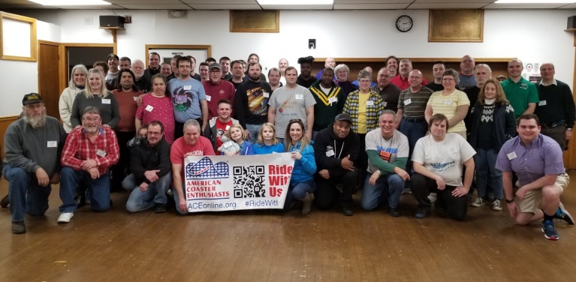

2019
Great Nor’Easter
Group Photo

DIRECTIONS & PARKING
Use employee entrance opposite 96 N. Policy Street, Salem, NH

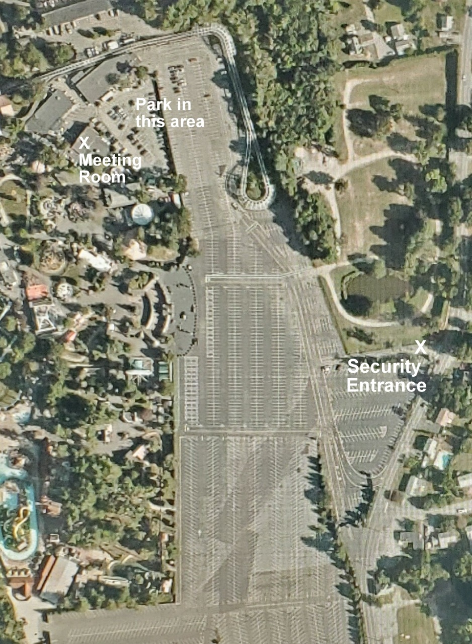
Also happening during the event….
THE SIXTH ANNUAL
ACE NEW ENGLAND PHOTO CONTEST
At The Great Nor’Easter

(contest outline/rules attached)

Attendance at this event is voluntary, and all participants release and hold harmless the American Coaster Enthusiasts Worldwide, Inc., its Officers, Directors, Executive Committee members and representatives, as well as Canobie Lake Park, from any and all liabilities related to those activities. ACE and Canobie Lake Park cannot be held responsible for delays, changes or cancellations of activities due to inclement weather, equipment problems or other unforeseen circumstances.

ATTENTION ROLLER COASTER PHOTOGRAPHERS!

THE SIXTH ANNUAL
ACE NEW ENGLAND PHOTO CONTEST
At The Great Nor’Easter
Canobie Lake Park
February 29, 2020

ACE members love to take photos of roller coasters while visiting amusement parks. Now is the chance to submit your favorites to share in a photo contest, open to all ACE members who attend the event!

Contest Rules:

ACE members attending the event may submit up to three photos for the contest. Photos should be no smaller than 8 by 10, or larger than 11 by 14 inches, and be without borders. Each photo must be roller coaster related, must show an existing or defunct roller coaster, and must have been taken by the entrant. No on-ride photos will be accepted.

Each photo needs to be identified with the name of the person entering, their ACE membership number, the name of the coaster and the park where the coaster is located. Those wishing to submit photos must arrive by 10:30 a.m. to allow for the photos to be registered and displayed. NO photos will be accepted after 10:30 a.m.

The photos will be on display during the event. One ballot will be issued to each attendee upon arrival, who will vote for their 3 favorite photos. Each photo with a first place vote will earn 3 points; each second place vote will earn two points; each third place vote will earn one point. Only one vote per photo will be permitted, and a vote for 1st, 2nd and 3rd must be cast, or entire ballot will be invalidated.

Prizes will be awarded by popular ballots for 1st, 2nd and 3rd favorite photos.

Winning photos, with the permission of the photographers, will be kept and automatically entered in the ACE Coaster Con 43 photo contest, being held in June. Remaining photos will be returned at the end of the event.

