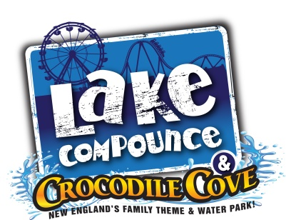
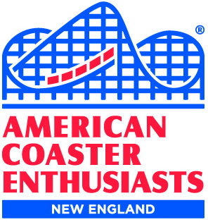
The New England Region of
American Coaster Enthusiasts
and
Lake Compounce
present

THE GREAT NOR’EASTER
2018

Saturday, March 17, 2018
10 a.m. to 4 p.m.
(check in begins at 9:30 a.m.)

~~~ LAKE COMPOUNCE WILL BE PROVIDING LUNCH ~~~
Please advise of any food allergies when you RSVP

Park Reps! Door Prizes! Food! Videos!
Sales Tables! Games! Other Surprises!

If you’ll be joining us, you must contact Rus Ozana by March 10 so we can plan for lunch:
rozana@ACEonline.org or call 617-816-9943

Due to space/seating limitations, only ACE members may attend (sorry, no guests).

A suggested donation of $5 per person will be taken at the door.

LOCATION
Training Room above The Croc restaurant
Check in begins at 9:30 a.m.

DIRECTIONS

Use the regular entrance (via the parking booths)
https://www.lakecompounce.com/hours-and-directions/directions

PARKING

Leaving the first 2 rows for those who require them, use the handicapped parking lot

Also happening during the event….

THE FOURTH ANNUAL
ACE NEW ENGLAND PHOTO CONTEST
At The Great Nor’Easter
Lake Compounce

(contest outline/rules attached)

2016 Nor’Easter Photo
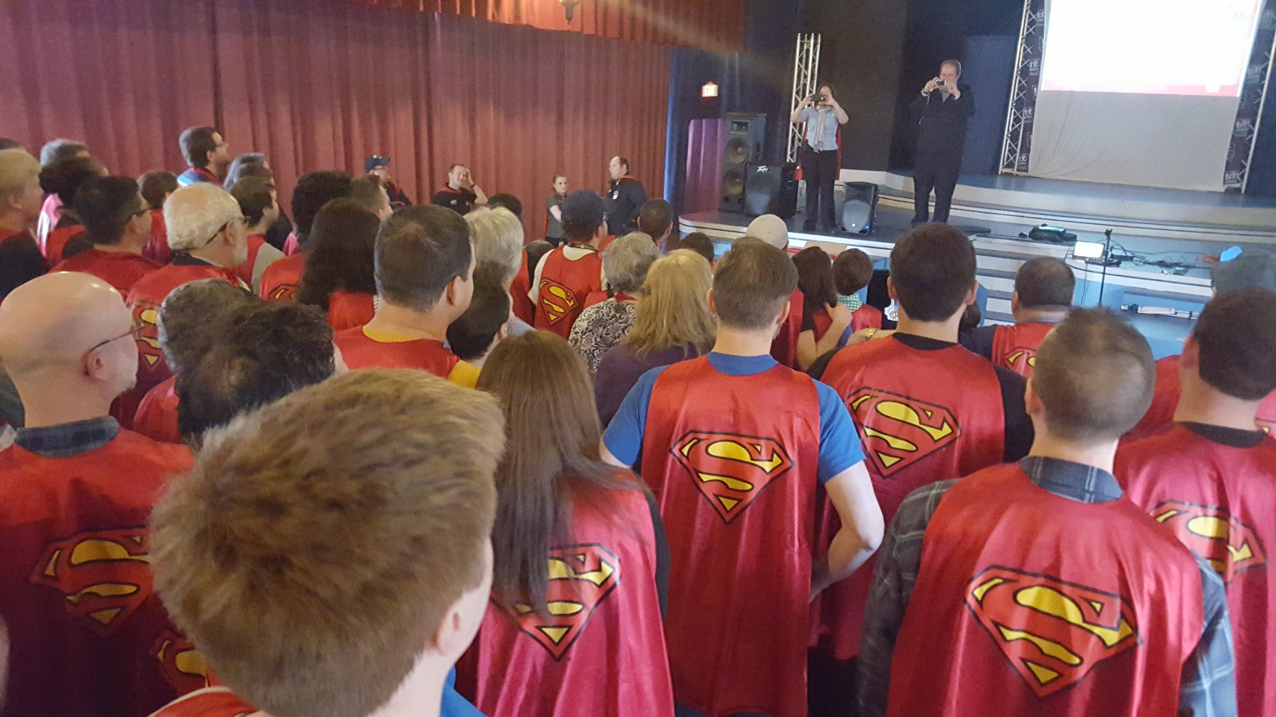

* * * * *

Attendance at this event is voluntary, and all participants release and hold harmless the American Coaster Enthusiasts Worldwide, Inc., its Officers, Directors, Executive Committee members and representatives, as well as Lake Compounce, from any and all liabilities related to those activities. ACE and Lake Compounce cannot be held responsible for delays, changes or cancellations of activities due to inclement weather, equipment problems or other unforeseen circumstances.

ATTENTION ROLLER COASTER PHOTOGRAPHERS!

THE FOURTH ANNUAL
ACE NEW ENGLAND PHOTO CONTEST
At The Great Nor’Easter
Lake Compounce
March 17, 2018

ACE members love to take photos of roller coasters while visiting amusement parks.
Now is the chance to submit your favorites to share in a photo contest –
open to New England ACEers only!

Contest Rules:

ACE members of Region 1 (New England states: Connecticut, Maine, Massachusetts, New Hampshire, Rhode Island and Vermont) may submit up to three photos for the contest. Photos should be no smaller than 8 by 10, or larger than 11 by 14 inches, and be without borders. Each photo must be roller coaster related, must show an existing or defunct roller coaster, and must have been taken by the entrant. No on-ride photos will be accepted.

Each photo needs to be in an envelope with the name of the person entering, their ACE membership number, the name of the coaster and the park where the coaster is located. Those wishing to submit photos must arrive by 9:30 to allow for the photos to be registered and displayed. NO photos will be accepted after 10:30 a.m.

Members who cannot attend who wish to submit photos may have another member submit the photo for them, or they may mail their photo(s)* by March 10 to:
Emery Picotte, 473 Broad Street, 3rd Floor, Cumberland, RI 02864-7823.

The photos will be on display during the event. One ballot will be issued to each attendee upon arrival, who will vote for their favorite photos. Each photo with a first place vote will earn 3 points; each second place vote will earn two points; each third place vote will earn one point. Only one vote per photo will be permitted, or entire ballot will be invalidated.

Prizes will be awarded by popular ballots for 1st, 2nd and 3rd favorite photos.

Winning photos, with the permission of the photographers, will be kept and automatically entered in the ACE Coaster Con XLI photo contest, being held in June. Remaining photos will be returned at the end of the event.

*Entries submitted by mail must also include a self-addressed stamped mailer with adequate postage for their return.

