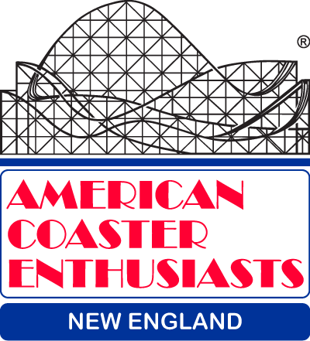
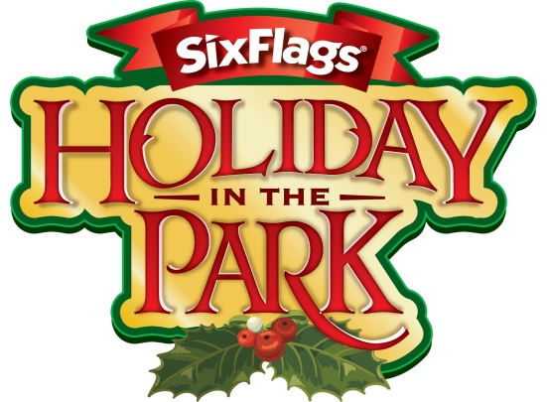
ACE New England
joins
Six Flags New England for

Holiday In The Park
Media/VIP Day

Saturday, December 2, 2017

Sign-in: 2:30-3:30 pm
(festivities offered at Rockville until event official kicks off for 3:30 p.m.)
Who can attend? ACE members with a current membership (sorry, no guests)
Cost? FREE!
Event Schedule:
- 3:30 pm- John Winkler and Jennifer McGrath offer overview of the event and new offerings for Holiday In The Park
- 3:30 pm-4 pm- Attendees are invited to interact with new characters and snack on cookies, hot cocoa and other festive treats
- 4 pm- Attendees experience Holiday in the Park Show in Rockville (closed to the public for the private event)
- 4:45 pm – Attendees are invited to a designated standing area to view the tree lighting
- 5:15 pm – VIPs are invited to experience Holiday in the Park with their family and friends

What to bring? We are encouraging all guests to bring a new, unwrapped toy for Dare Family Services (Foster Care System) – this is totally optional.
Everyone will receive a free raffle ticket to
select an attendee and their family
to light the tree!

To attend, you must RSVP by November 27 to Rus Ozana at rozana@aceonline.org (or call 617-816-9943 and leave a message) and indicate the number of ACE members attending.

As this is an event with assorted media/reporters, we want to ensure we represent
ACE in the best light. You do NOT need to ‘dress up’, but do feel free to wear your
holiday flair (Santa hats, reindeer ears, etc,) and of course, no visible park logos
other than Six Flags. Thank you!

