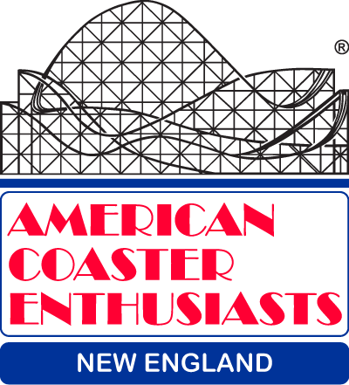

PRESENTS

ACE DAY at

BERKSHIRE EAST MOUNTAIN RESORT
Charlemont, MA

Sunday, May 3, 2015

What better way to spend the day after Wooden Warrior Day, than to attend ACE New England’s first-ever ACE Day at Berkshire East Mountain Resort?

For just $40 per person, you get a full day of unlimited rides on Thunderbolt Mountain Coaster,
lunch, soft drinks, and a cash bar.

You will also have the option of the Base Zip Tour, Mountain Top Zip Tour or Valley Jump Zip Tour
for an additional fee*. Details of these options can be found at: https://vimeo.com/123674580

Schedule:

9:30 a.m. Arrive at Berkshire East Mountain Resort to check in and sign required waivers.

10 a.m. – 4 p.m. Berkshire East Mountain Resort open to the public and you.

12 – 1 p.m. – Lunch – Q&A with resort staff. Cash bar will remain open all afternoon.

While there is no pre-registration, in order for the resort to be ready for us, an attendance figure is needed. Please email Rus Ozana: rozana@aceonline.org by April 30 if you will be attending (or call Rus at: 617-816-9943).

*Additional fees:
Base Zip Tour - $10
Mountain Top Zip Tour - $75
Valley Jump Zip Tour - $100

Directions to Berkshire East Mountain Resort
http://www.berkshireeast.com/plan/directions-to-berkshire-east-mountain-resort/

ACE Disclosure: The payment of fees by, for, or on behalf of participants, releases and holds harmless the American Coaster Enthusiasts Worldwide, Inc. and its Officers, Directors, Executive Committee Members and representatives, as well as Berkshire East Mountain Resort, from any and all liabilities related to those activities. Members are also responsible to abide by ACE's code of conduct at all times during the event, and are also responsible for the conduct of their non-member guests. ACE and Berkshire East Mountain Resort cannot be held responsible for delays or cancellations of ride times due to inclement weather, equipment problems or unforeseen circumstances.

NO REFUNDS NO RAIN CHECKS NO EXCHANGES NO WHINING

