THIS IS A SAMPLE FLIER FOR THE EVENT

It’s The 15TH ANNIVERSARY OF

Oc~Boulder~Fest!

Date to be announced, 2015

For 2015, you get a full day admission to "The Lake”
and 1 hour evening ERT on

Boulder Dash Mountain Coaster

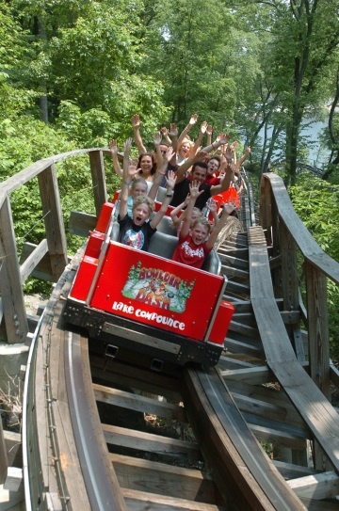

after the park closes!
Park hours are 11 a.m. to 9 p.m.

FREE PARKING!* PLUS A POSSIBLE CATERED PICNIC LUNCH!

*Free Parking: Pay at the parking booth. Bring your receipt to the check-in tables for reimbursement!

Schedule (to be determined):

11 a.m. to 12 noon – Check-in
11 a.m. to 9 p.m. – Lake Compounce open to the public and you
12 – 2 p.m. - Buffet Lunch
9 p.m. – 10 p.m. ERT on Boulder Dash

All of the above for a price to be determined. (Discounted for Lake Compounce Season Passholders)

"Midway Moolah" will be available for purchase at a 10% discount during registration,
and can be used for food, merchandise, and Midway Games.
(Soft drinks at LC are FREE)

There will be Door Prizes and a
special raffle option for a 2016 Season Pass!

How to register:
There is no on-site registration.
Your payment will be made on-line using PayPal.
Registration is $__per person. If you have a Lake Compounce Season Pass, it’s only $__!
No other discounts or offers apply.
There is no charge for children 0-3 years of age.

Registration Deadline to be determined

Questions? Call Rus Ozana at 617-816-9943

NO MATERIALS WILL BE MAILED TO YOU.
All attendees must pick up their admission materials on-site on the day of the event.
On [event date], come to the Park between 11 a.m. and 12 noon.
Check-in tables will be set up 'under the bridge' at the entrance to the park.

This event is open to any and all roller coaster, amusement park, water park
and Lake Compounce fans.
You need not be a member of any coaster club to participate in the fun.

Directions to Lake Compounce
Minutes from I-84, Exit 31. Two miles North on Route 229 and
follow the signs.

GPS directions, please use:
186 Enterprise Drive, Bristol, CT 06010

By participating in this event, you agree to abide by all posted and verbal rules
of Lake Compounce, including (but not limited to) the use of all safety and restraint devices on the rides.

This event schedule is subject to change due to inclement weather, equipment problems,
or other unforeseen circumstances.

Lake Compounce weather policy:
“The park will be open the day of the outing. We cannot offer refunds, rain checks, or rain dates.”

*Menu subject to change

